Miracle Assistance Dogs Inc.

Information Pack
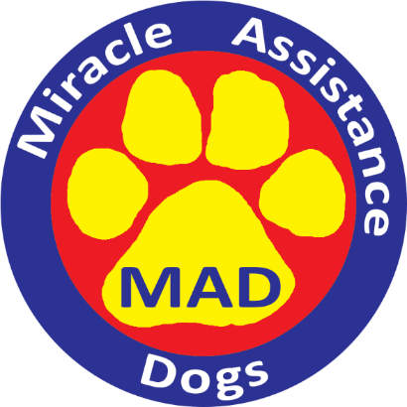
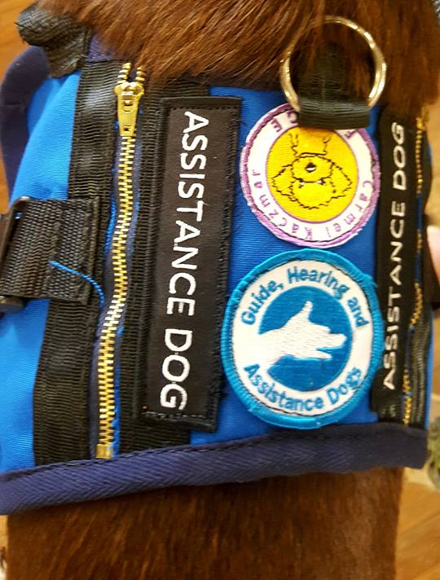
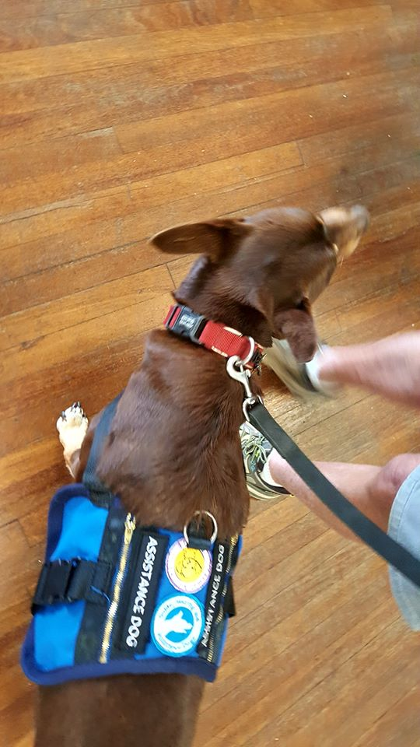

TABLE OF CONTENTS
Contents
Introduction 3
Mission Statement 3
Vision 3
Profile of Carmel (Fudge) Kaczmar 4
What it means to have an Assistance Dog in relation to legislation? 4
Privacy & Confidentiality Statement 5
Services Provided By Miracle Assistance Dogs Inc. 5
Examples of Task Training 6

Introduction
Miracle Assistance Dogs Inc. (MAD) is a volunteer based organisation that provides administrative support to Carmel (Fudge) Kaczmar Approved Assistance Dog Trainer and Hearing Dog Trainer under the Guide, Hearing and Assistance Dog Act 2009 (QLD). Carmel trains Assistance Dogs to assist children and adults living with physical and psychiatric disabilities.
Puppies grow up and create Miracles that change the lives of people living with disabilities, so that they may enjoy life with greater independence.
Individuals are also provided with training for both them and their dogs in order to become an accredited Assistance Dog Team.
Carmel conducts the Public Access Test under the Guide, Hearing and Assistance Dog Act 2009 (QLD).

Please Note: Miracle Assistance Dogs Inc. (MAD) is applying to become an Approved Training Institution with Queensland Government Guide, Hearing and Assistance Dogs (GHAD).
The Statements below reflect the organisation’s future mission statement and vision once approval has been achieved.

Mission Statement
To enrich the lives of those living with disability through the training of highly skilled and reliable Assistance Dogs, and by being a leading provider in our field.

Vision
To empower those living with disability to gain independence and lead more fulfilling lives by providing highly trained Assistance Dogs and developing community participation.

Profile of Carmel (Fudge) Kaczmar
Miracle Assistance Dogs was founded in 2011 by Carmel FUDGE Kaczmar, her husband, John, and a loyal team of volunteers.
Fudge is an Approved Assistance Dog Trainer and Hearing Dog Trainer under the Guide, Hearing and Assistance Dog Act 2009 (QLD), as well as a Technical Assessor contracted to assess individuals who have applied for approval as Assistance Dog and Hearing Dog Trainers through the Department of Communities, Disability and Aging, (QLD).
She holds a Certificate IV in Companion Animal Services (Delta), is a full member of the Professional Pet Guild of Australia (PPGA) and has appeared as an expert on RSPCA Animal Rescue.
Her expertise has been sought by legal professionals, council rangers, veterinarians and animal trainers. Carmel is a sought after public speaker and has presented many seminars on Dog Training and working with Assistance Dogs. Carmel is available for speaking engagements and can be contacted by emailing info@miracleassistancedogs.org.au .

What it means to have an Assistance Dog in relation to GHAD legislation?
An assistance dog must be certified by an approved assistance dog trainer. An assistance dog must meet the following criteria:
- The assistance dog is able to perform identifiable physical tasks and behaviours to assist the person in a way that reduces the person’s need for support; and
- The assistance dog has passed a public access test conducted by an approved trainer and task certified within 7 days of the public access test.
- The assistance dog must not be a restricted breed as defined under the Local Government Act 1993;
- The assistance dog must be desexed and vaccinated;
- The assistance dog has not been declared a dangerous dog under a local law.
- The handler of the dog in training to be an Assistance Dog needs to enter into an agreement regarding compliance with GHAD and other Australian Federal, State or Territory legislation.

Privacy & Confidentiality Statement
Miracle Assistance Dogs Inc. abide by the principles in the Privacy Act, 1988.
Under Privacy laws you have the right to find out what information is collected about you, why we are collecting the information, if the information collected is compulsory under other legislation and what we are going to do with it. You also have rights to access and correct any information held about you.

At Miracle Assistance Dogs Inc. we have taken all reasonable steps to store your information securely to prevent its loss or misuse.

We only use personal information collected via our website or provided by you for the purpose for which it was provided and to meet legislative requirements. Miracle Assistance Dogs Inc. does not sell or pass on personal information to third parties, except where your consent has been provided in writing. Miracle Assistance Dogs Inc. will retain your information and provide it to Carmel (Fudge) Kaczmar and Guide, Hearing and Assistance Dogs Inc. for the completion of purposes under which you provided the information.

Your information contained within our database may be amended or deleted by emailing Miracle Assistance Dogs Inc at info@miracleassistancedogs.org.au . All reasonable steps will be taken to delete your personal information, upon receiving your request in writing, except where that information is required to be retained for legal reasons.

You can obtain a copy of Miracle Assistance Dogs Inc. Privacy and Confidentiality Policy by emailing info@miracleassistancedogs.org.au

Services Provided By Miracle Assistance Dogs Inc.
- Obtaining an Assistance Dog – Miracle Assistance Dog Inc. have trained an Assistance Dog and provide it to the client. Further training is provided to the client to enable them to successfully complete the Public Access Test (PAT) and certification. Miracle Assistance Dogs Inc. retains ownership of the dog.
- Join the Owner Training Assistance Dog Program – this is currently conducted by Fudge where your own dog is trained to be an Assistance Dog.
- You provide a contribution of $20,000 to Miracle Assistance Dog towards the training of an assistance dog for you.

Examples of Task Training
Below are the tasks that Assistance Dogs can be trained in with examples of each type of task.
TASKS | EXAMPLES
Retrieval | - Fetch items including disability supports  - Retrieve dropped items  - Assist in tidying house etc.
Carrying | - Carrying items from one location to another  - Dog carries a pre-arranged item to carer to signal that help is required etc.
Deposit | - Put items in the trash or recycle bins  - Put prescriptions, mail and other items on a counter top, etc.
Tug | - Open and close doors  - Answer doorbells  - Assist with removing clothing, etc.  - Hearing Alert
Nose  Nudge | - Closing doors and drawers  - Calling emergency services  - Pushing buttons,  - Use light switches, etc.
Pawing | Same as Nose Nudge
Bracing | - Brace to prevent handler falling  - Steadying handler, etc.  - Limited Mobility or needing physical support
Harness | - Helping handler to walk with Balance  - Transporting items in backpacks, etc.
Other | - Physical alert to alarms  - Search for lost items  - Find carer and lead to handler, etc.  - Interrupt repetitive behaviour  - Mental Health (grounding etc)
Medical | - Call emergency services  - Fetch medication in case of crisis, etc.  - Diabetic Alert (low and high blood sugar)  - Seizure Response  - Rare disorders and disabilities

